Water and fire
I recently read an article about St Patrick’s Roman Catholic Cathedral in Melbourne, Australia, which has a beautiful water feature cascading down the middle of the wide pathway that leads to and from the building. (It’s worth looking at this online).
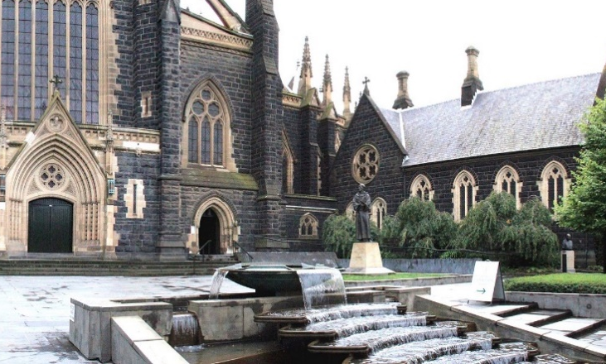
At the far end of the cascade of water there is a large inscription which reads:
Incarnate Word
in whom all nature lives,
cast flames upon the earth.
Raise up contemplatives among us
those who walk within the fire
of ceaseless prayer, impetuous desire.
Set pools of silence
in this thirsty land.

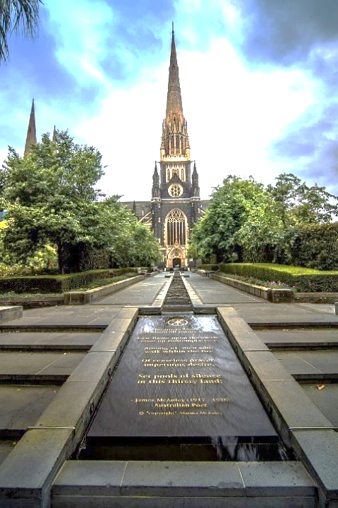
(This is an excerpt from a poem entitled ‘A Letter to John Dryden’ by James McAuley – and in the original version, the line beginning ‘those who walk’ in fact begins ‘men who walk…’)
These words speak to me in many ways. I will offer two of these here (and you may find other things).
First: I am struck by the interweaving of the imagery of fire and water, especially in relation to contemplative or silent prayer. In fact, both of these themes have featured in our Stilling Prayer over the last couple of months, as I reflected on Wellsprings of Stillness in April, and Jim gave us his meditation on the Fire of the Holy Spirit in May. And even though fire and water could be seen as opposites in certain contexts, our Christian tradition seems perfectly comfortable with making the rich combination of imagery of water and fire to denote the work of the Holy Spirit in our hearts. Both water and fire represent purifying and cleansing, which we all need in our inmost selves. And we can be taken up into the stream of Christ’s living water flowing through our lives, at the same time as our hearts burn with love for God and for the world. The key thing is to let the imagery carry us more deeply into God, rather than trying to over-analyse each metaphor!
Second: I find a sense of urgency here, in the poet’s emphasis on how much the world needs people who pray: ‘contemplatives who walk within the fire of ceaseless prayer, impetuous desire’. I have long believed that, whenever we pray, we are there, before God, not only for ourselves, but as channels of divine love for the world. This includes wordless prayer just as much as spoken intercessions, and resonates with the strong desire expressed in the lines: ‘Raise up contemplatives among us,’ and ‘Set pools of silence in this thirsty land.’ I believe this is a call and challenge for each of us.
A prayer to lead us into silence
Beloved Christ, open our hearts
to your waters of stillness and to the flame of your love,
to cleanse and renew our own lives,
and for the blessing and restoring of your ‘thirsty world’. Amen.

After the silence
Love of Jesus, fill us,
Joy of Jesus, surprise us,
Peace of Jesus, flood us,
Light of Jesus, transform us,
Touch of Jesus, warm us,
Strength of Jesus, encourage us.
O Saviour, in your agony forgive us,
In your wounds hide us,
And in your risen life take us with you.
(Inspired by the 14th century prayer ‘Anima Christi’, Soul of Christ, sanctify me)

