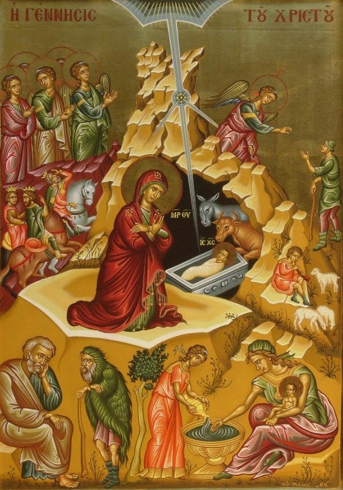

**The Heart of Stillness**

In his speech at the re-opening of Notre Dame Cathedral a couple of weeks ago, President Macron recalled an amazing event which had taken place during the fire which had devastated the building. While the Cathedral was ablaze, and beams, rafters and eventually the spire were crashing to the floor, one item remained unmoved amongst all the chaos around it. This was the statue of the Virgin Mary holding the Christ Child.

Through their iconography, Eastern Christians are very familiar with the entrance of Christ into His world being portrayed as the heart of stillness amid frenetic surroundings. Many icons take their lead from *The Gospel of James,* which was probably written between 100 and 150 years after the Holy Birth, and was designed to fill in some of the gaps in the accounts of St Matthew and St Luke. Of course, it must be read as a symbolic rather than a literal account of the Holy Nativity.

Thus, Christ is born in a cave, not in a stable. The cave symbolizes the human heart, which must be ready to receive the Holy Child and the stillness which His presence confers on those who are open to Him. In addition to the shepherds, the wise men and the angels we find the ox (which is a kosher animal) and the ass (which is unclean), representing the Jewish and Gentile believers who will follow Christ. We also find Joseph in conversation with an old demonic man, who is trying to cast doubt on Mary’s virginity, and the midwives going about their business. In the midst of all this frenzied activity, Mary adores the Christ Child as both her Son and her Lord, seemingly oblivious to what is going on around her.

Christ is the mystery hidden throughout all ages, just as His coming in the cave was hidden from most people. But the glory of this mystery is Christ in us (see Colossians 1 verses 26-27). In this way, the cave becomes an icon of every heart that opens itself to Christ.

Caves, with all their mystery and darkness, hidden chambers and secret places, are truly a reflection of the dark, mysterious heart within each one of us. But like the cave Christ entered on Christmas Day, our hearts can become the dwelling place of His majestic glory. Like the ox and ass, we have both clean and unclean things in our hearts – the things that are good and not so good. We have the demons whispering doubts or evil things to us. But we also also have Mary the Mother of God praying for us. All the distractions in our lives pull us out of our hearts, and away from stillness. Because of that, we have a problem with self-awareness. But when we enter into our hearts, we find that Christ is there, we find the stillness that He wants us to have. May Christ our God enfold you in His stillness this Christmas.

**We enter into the stillness** with the words of St Kallistos and St Ignatios of the 14th century:

Spiritual knowledge comes through prayer, deep stillness and complete detachment, while wisdom comes through humble meditation on Holy Scripture and, above all, through grace given by God *(On the Life of Stillness 68).*

**We leave the stillness** with the words of Niketas Stithatos of the 11th century:

Stillness is an undisturbed state of the intellect, the calm of a free and joyful soul, the tranquil unwavering stability of the heart in God, the contemplation of light, the knowledge of the mysteries of God, consciousness of wisdom by virtue of a pure mind, the abyss of divine conceptions, the rapture of the intellect, intercourse with God, an unsleeping watchfulness, spiritual prayer, untroubled repose in the midst of great hardship and, finally, solidarity and union with God *(On the Inner Nature of Things 64).*