**From Wandering to Wondering**

One of the best known of Jesus’ parables is The Prodigal Son (Luke 15: 11-32), and it’s one that I often return to.

It’s quite easy for us to view the story of the rather wild younger son with a degree of disapproval - *we* would never be like that! (That, of course, is alarmingly close to the viewpoint of the worthy older brother in the story; there’s no time today to explore his indignant response, but this could be food for further reflection at a later time!) Going back to the younger brother, it’s true that he does behave pretty badly! He cheekily demands his share of the family inheritance, even before his father has died. He then **wanders off** to a distant land, where he squanders the whole lot in what the Gospel tactfully calls ‘loose living’. And it’s only when he is utterly poverty-stricken and desperate that he decides to go back home and throw himself on the mercy of his father, in the hope that he might at least get enough to eat as a hired servant. Of course, we think to ourselves, we would never behave like that!

And yet, most of us do at some time or another, **wander off** from our better selves and from what we know to be right, wise and good. And we do sometimes allow ourselves to drift away from our closeness to God. This can happen in lots of different ways. It may be that demands, preoccupations and external pressures are so great that we allow ourselves to wander away from our regular prayer and centredness in God. Or perhaps we wander into a wilderness of resentment, or grievance or gossip, or over-concern with our own reputation or control. Whatever it is, most of us do have moments when, to quote the Book of Common Prayer: ‘we have erred and strayed from thy ways like lost sheep’! (Interestingly the Parables of the Lost Sheep and Lost Coin occur in the same chapter 15 of Luke’s Gospel, so that, along with the ‘lost son’, Jesus gives us three complimentary images of our common human tendency to wander off and become, as it were, ‘lost’.)

But then comes hope and redemption in the story. I love the verse which says that when this chap was in the depths of misery and hunger, working in a pigsty, ‘he came to himself’ (v.17). And when we, in our turn, come to ourselves, and re-connect with our better and wiser nature, we may also realise that our only option is to return to our loving Father, God, who has been waiting for us all along.

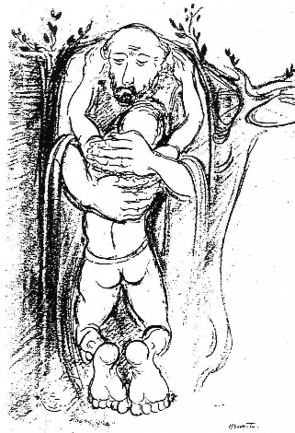

The next scene is well known: the Father does not rebuke or punish his son, as we might expect, but hitches up his robes and runs to meet him (something unheard of for a dignified patriarch in the Ancient Near East). He then embraces his son and kisses him, calling for a party to celebrate his return. The parable doesn’t spell out how the son himself feels about this, but, given the fact that he had intended to say, ‘I’m no longer worthy to be called your son; treat me as one of your hired servants’, it must have been a **wonder**ful surprise to be welcomed with love and healing compassion. So he has moved from wandering to wondering. And I am thinking, with sadness, how many people today still assume that God’s default position is one of wrath, vengeance and retribution, and we have somehow to be good enough to win his love back. Yet in this parable we see a situation where the son must **wonder** at such depths of compassion, mercy and generosity, beyond all the norms and expectations of the time.

So, for us, whenever we realise that we have wandered away from closeness to God and from our better selves, we too can return to God our Father, in sorrow and penitence, and wonder at the divine mercy and loving acceptance that comes to meet us, even in our frailty and confusion. And quiet, stilling prayer is one good way to re-engage our hearts and open our whole being to the creative, restoring energy of God.

**To lead us into silence**: a prayer from the book of reflections entitled *Meister Eckhart’s Book of the Soul* by Mark Burrows and John Sweeney (p. 41)

How should I prepare to find you?

In emptying myself of the chatter

of my words, and opening myself

to the silence that allows me

to risk an unknowing that expects

nothing, and deserves nothing,

and wills nothing, other than

the word you speak in

the stillness I keep, *where*

*my wandering ceases and*

*my wondering begins? (my italics)*

**To end the silence**:

Loving Father,

we have sinned against heaven and against you,

and feel unworthy to be called your children.

Yet we turn to you again,

and ask you to have mercy on us.

Bring us back to our truest and best selves;

bring us back to *your*self,

as those who once were dead

but now have life in Christ;

who once were lost, but now are found.

Thanks be to God. Amen

*Patterns for Worship, Church of England 1989, adapted*