**Filled with all the fullness of God**

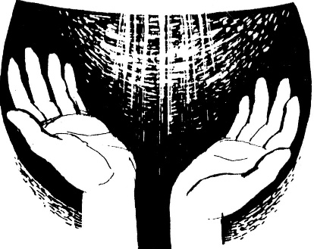

There’s a passage in St Paul’s Letter to the Ephesians that is so bold that it strikes me afresh almost every time I read it. It’s Chapter 3 verses 18 to 19, where he says:

‘I pray that you may have the power to comprehend, with all the saints, what is the breadth and length and height and depth, and to know the love of Christ that surpasses knowledge, so that you may be filled with all the fullness of God.’

The first part of this quote is amazing enough, reminding us how vast and infinite Christ’s love is. But then the words become even more extraordinary, as we are invited not only to ponder the immensity of divine love, but also to be filled with this mysterious, loving ‘fullness of God’ ourselves!

I remember in the past feeling that this whole notion of being ‘filled with all the fullness of God’ was totally beyond me. But this changed at a time when I had been feeling rather a failure in prayer and trust, and came across the wise teaching that it is precisely when we’ve got very little of our own to offer that there is space in us for God to fill. That’s why the people whom Jesus found it hardest to reach were the Scribes and Pharisees: they were so full and cluttered up with their views and sense of their own spiritual superiority that there was hardly any room left inside them for God to get in.

I think this is what Jesus is getting at when he says, ‘Blessed are the poor in spirit, for theirs is the kingdom of heaven,’ (Matthew 5:3). I like the first New English Bible translation of this: ‘Blessed are those who know their need of God.’ In other words, it’s particularly when we recognise and acknowledge our spiritual need and perhaps emptiness that we can be filled with God’s transforming presence and redeeming love. It’s all gift and grace.

Sometimes we may face a painful or difficult situation which is itself a kind of emptying – a wilderness or desert experience where everything seems to be stripped away and all we have is God. The problem is that, at such moments, it’s not always easy to muster the faith, confidence or energy to offer our emptiness to be ‘filled with all the fullness of God’. Perhaps all we can do at such times is rest in the prayers of others and in the fullness of love that we know surrounds and holds us, even though it may not feel like that at the time.

Finally, our ‘stilling prayer’ can itself be a kind of emptying, as we let go of surface preoccupations and everyday pressures and demands, in order to make more space for the Spirit of God. Our weekly theme that Stephen circulates to us all helps us to focus on the God who is with us, making it easier to become quieter and more inwardly still as we settle into God’s loving presence. But sometimes this kind of silent or contemplative prayer is misunderstood. Someone once said to me, ‘That’s dangerous, because if you empty your mind the devil can get in!’ The best response I’ve heard to that is from Fr Laurence Freeman speaking to the Christian Meditation Community. He reminded us of the 4th century desert teaching, that when a person is open, empty and receptive before Christ, the demons run a mile!

**To lead us into silence** here's a quote, from John Dalrymple’s book ‘*Simple Prayer*’;

‘Contrary to popular misunderstanding, we are only seeking to empty our mind of mundane things in order to fill it with God. … We may well find ourselves too full of the richness of God to want to analyse - just content to dwell in wonder, like the eye dazzled by light.’

**Prayer to end the silence**

Behold, Lord, an empty vessel that needs to be filled. My Lord, I ask you to fill it.

I am weak in the faith; strengthen me.

I am cold in love; warm me, that my love may go out to my neighbour.

I do not have a strong and firm faith; at times I doubt and am unable to trust you altogether.

O Lord, help me and strengthen my faith and trust in you.

*Martin Luther (1483-1546)*