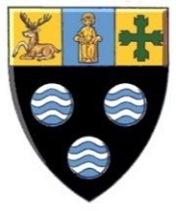
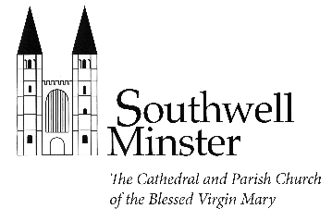
SOUTHWELL MINSTER

VISITING CHOIRS

Visit Request Form

Thank you for your interest in coming to Southwell Minster as a visiting choir. Please fill in this form and return it to the Liturgy and Music Administrator (litmus@southwellminster.org.uk). Your request will be considered by the Liturgy and Music Department and the Cathedral Diary Committee, and we will let you know the result as soon as possible.

Name of choir: Click or tap here to enter text.
Date(s) of visit: Click here to enter text.

Conductor’s contact details: Name, email address, phone number, etc.
Administrator’s contact details: Name, email address, phone number, etc.; or n/a

How many singers are in your choir (approximately)? e.g. 30

What experience, if any, do you have of singing services at cathedrals? Click here to enter text.

Is there anything else you would like us to know at this stage? Click here to enter text.

Signed: Name, date

